Data Base SQL Assessment:

Siddarth Nakati

Creating databases and Tables:

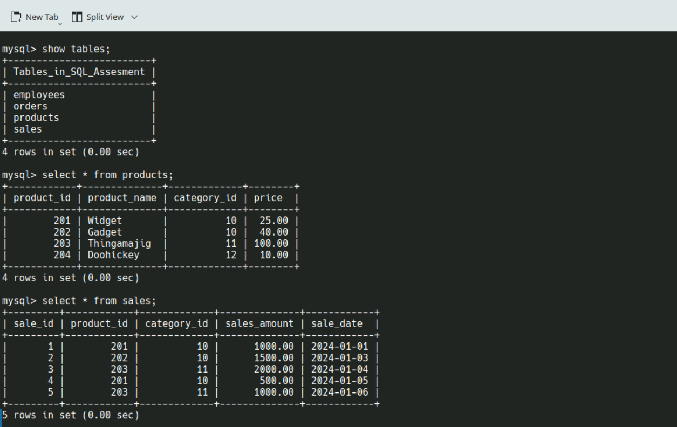

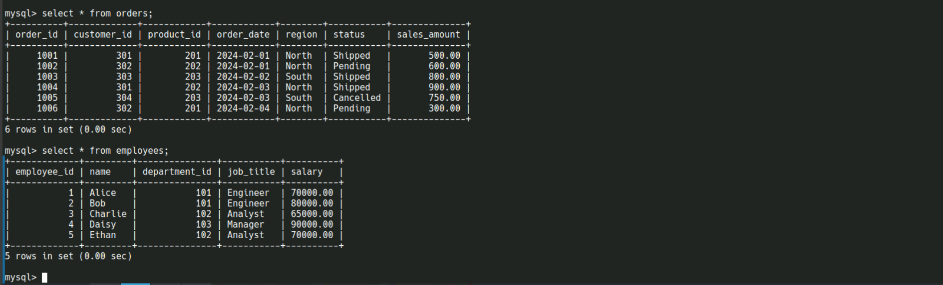

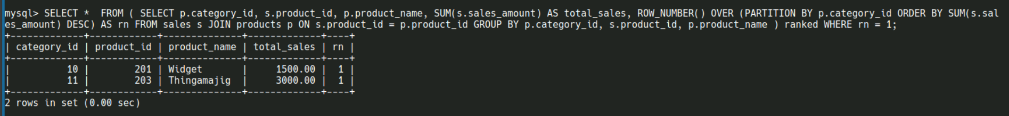Q1: List Top-Selling Product in Each Category

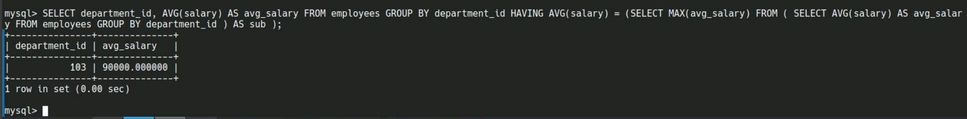Q2: List Department with the Highest Average Salary

Q3: List Employees Who Earn More Than Department Average

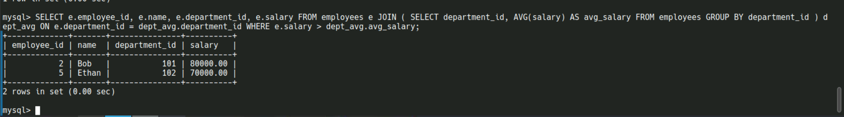

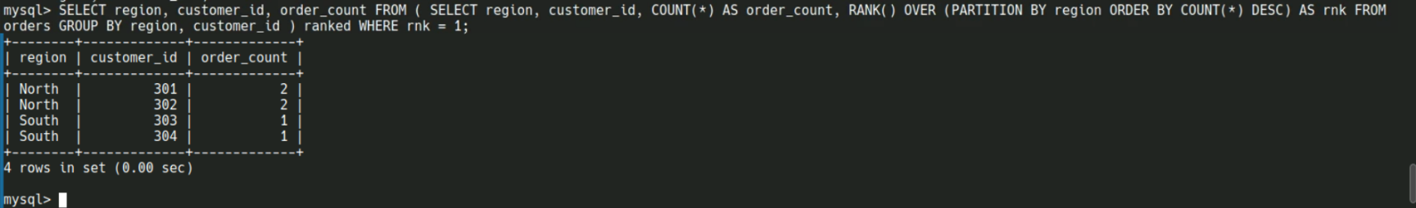Q4: List Customer with Most Orders per Region

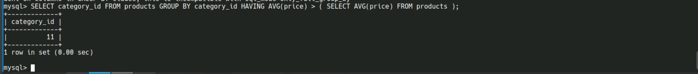Q5: List Categories Where Average Price > Overall Average Price

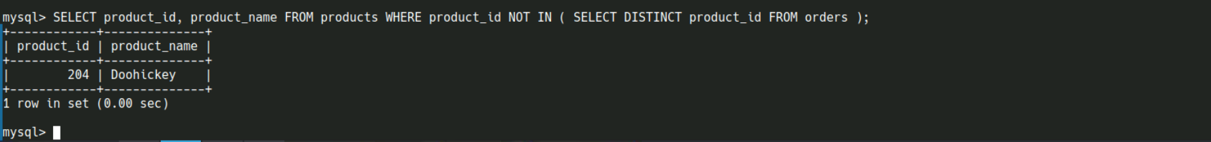Q6: List Products Never Ordered